In The Name Of God

( This is The End - All Chapters )

( PS 14 - Final Sample Questions)

----------------------------------------------------------------

1 - We are asked to program a management system for a senior high school. the system should be able to accept an unlimited number of students by using the linked list structure. the authorities should be able to add, delete, search any student by their name, student number, and national id. the information of each student that should be saved in the system are :

Student’s name and family name

Student’s lessons and scores of each lesson

Student’s national id and student number.

The authorities shall also be able to sort the student by their **GPA** and also in **alphabetical order** and also print their information in each wanted manner.

// notice that each student can have an unlimited number of lessons and each lesson can have an unlimited number of scores.

// you have to implement the students by linked list data structure.

2 - برنامه ای بنویسید که از کاربر معادله درجه n را بگیرد ، از عدد 1 تا200 را به عنوان ورودی به تابع پاس دهد و خروجی را بصورت نمودار در یک فایل بکشد .

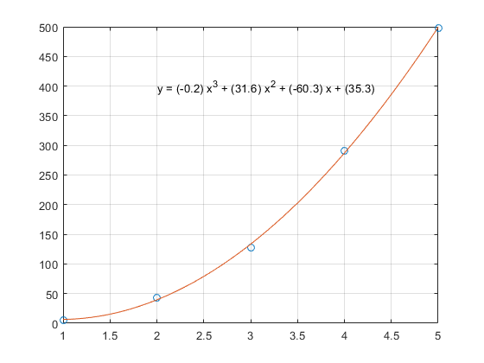

3 - Write a program that gets an input n from the user and prints the path we have to across to solve a hanoi problem with 3 bars and n rings.

( Hanoi Tower )

(Hint : See The Above Example )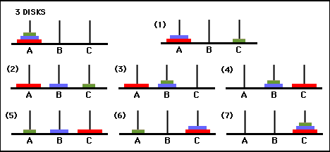

4 - assume that we are given a BST ( binary search tree ). Write functions to do the following tasks :

A - delete by data

B - balance the tree

C - Print the tree